CODEALPHA INTERNSHIP PROJECT REPORT

Project Title – Language Translation Tool
Submitted By – Gungun
- OBJECTIVE

The objective of this project is to develop a Language Translation Tool using Python. The application translates text from one language to another and provides a simple graphical user interface for users.

- TECHNOLOGIES USED
2.1 Python
2.2 Tkinter
2.3 Deep Translator Library
2.4 Visual Studio Code

- FEATURES
. User-friendly graphical interface
. Automatic language translation
. Fast and accurate translation
. Easy to use

- WORKING
  - The user enters the text in the input box.
  - The user specifies the target language.
  - The Translate button is clicked.
  - The application processes the text and translates it.
  - The translated text is displayed in the output box.

- OUTPUT

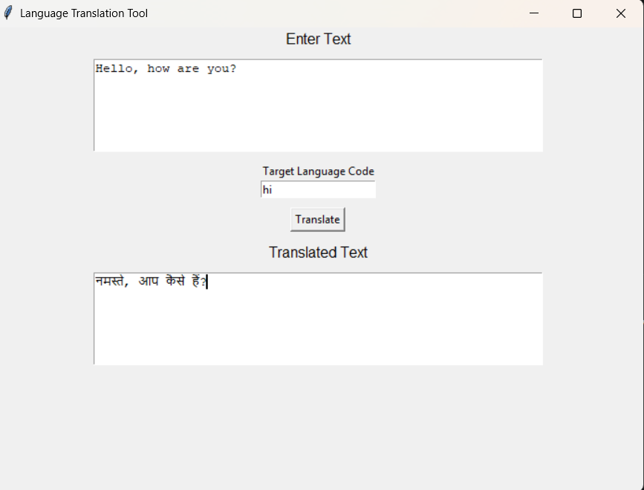
FIGURE 1: Output of the Language Translation Tool

- CONCLUSION
The Language Translation Tool was successfully developed using Python.
The project demonstrates the use of translation libraries and GUI development. It provides an efficient and user-friendly way to translate text between languages.

